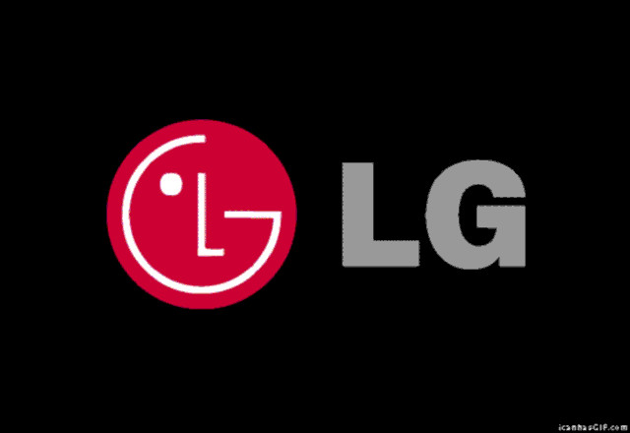

LG: Life’s Good for Everyone

Matt Brewer

Nov 27/18

BOH4M

Marchese

“The best leaders are not the ones that complete quickly, but follow through diligently” – Matt Brewer

Table of Contents

Section A: Overview

1. Full Company Name
2. Location
3. Industry
4. List of Products and Services
5. CEO + Graphic

Section B: Management

1. Organizational Structure
2. Management Functions
3. Management Style

Section C: Planning and Analysis

1. Growth Strategies
2. SWOT Analysis
3. Communication Policy

Section D: Human Resources

1. Recruitment Procedures
2. Training and Development
3. Retention Program

Section E: Social Responsibility

1. Socially Responsible

Section F: Motivation (Video or report)

1. What leads to Organization Success
2. How are employees Motivated

Section G: Case Scenarios for Success

1. Case Scenarios
2. Top 10 Tips
3. Visual Aid

Section H: Bibliography

Section A: Overview

**Full Company Name**

The full company name of LG is LG Corporation, which was formerly known as Lucky Goldstar.

**Location**

LG’s headquarters are in Yeouido-dong, a district in Seoul, South Korea.

The exact address of the company is: 128 Yeouin Street, Yeongdeungpo-gu,Seoul, 073-36,

Korea, Republic of (South).

**Industry**

LG industry falls heavily on providing high-quality home appliances and electronics, although they are beginning to be popular in providing reliable mobile phones.

**Products/Services**

LG offers a wide variety of products for their consumers to choose from. Their notable products are: Information Display, Monitor, Security, Air-Solution, EMS, Solar, ESS, Commercial Laundry, Styler, Lighting, Compressor & Motor, Vehicle Components, Membrane and Computer Products. Some services within LG include basic technical support, email support, and online support to give customers various options to voice their problems in order to get their problems solved. More advanced services include discussions on the company’s website and LG Direct Service which allows customers with warrantied and non-warrantied products to pay a lower price to fix their products. In addition, they have LG qualified technicians to come and fix the products that are broken which rival companies don’t invest as much time into.

**Mission Statement and Analysis**

LG’s mission statement is as follows: LG’s philosophy revolves around people, integrity and foundations. We strive to understand our customers; offer best in class solutions and new experiences through relentless innovation, thus helping our customers lead better lives. Of this mission statement, LG’s key market is to sell to people, whom they call customers. Their contribution to society provides best in class solutions and new experiences. They are distinguished from their competition by offering best in class solutions and experiences through relentless innovation. In analysis, I believe that this mission statement is well-developed.

The mission statement mentions that they use innovation with best in class solutions in order to understand customers. This is important to feature as customers are the cornerstone of everything that they are doing, as the main goal of any goal of any company is to generate profit, which requires the customer to spend their own money. However, this mission statement gives a perfect guideline of who their key market is, how their company contributes well to society and how the distinguish themselves from the competition.

**CEO and Graphic**

The CEO or Chief Executive Officer of LG is Jo Seoung-Jin. Seoung-Jin has been appointed as the CEO of LG on December 1st, 2016. He is one of two former Vice Chairman’s of LG 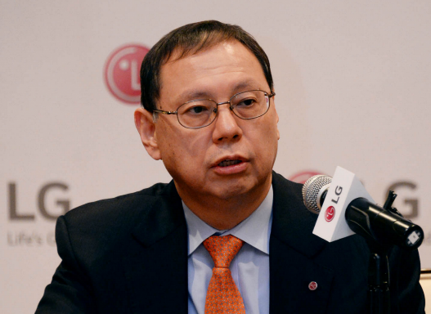Electronics Inc and has directed its operations since December 1st, 2015. Seoung-Jin has been affiliated with LG since December 1976, which shows that he is quite loyal to his company and has worked his way to the top through his experience. He is also the highest part of the Board of Directors whom control all business decisions within the company. More importantly, Seoung-Jin makes the decisions that Upper Management will send down the hierarchy for everyone to follow.

Section B: Management

**Organizational Structure**

**Management Functions**

LG utilizes Management Functions to utilize success by developing methods of planning, organizing, leading and controlling. As an organization, the corporation must organize effectively in order to function properly. LG Corporation uses organizing by having a purpose, a division of labour, and a hierarchy of authority. Their purpose as an organization is to offer best in-class solutions for home appliances and technology in order to generate profit. The company’s division of labour begins at the top, starting with human resources, accounting and marketing. The middle of the map is your supervisors, district managers and directors. The lower part of labour are your typical managers, supervisors, employees and custodial workers. LG Hierarchy begins with the CEO, Board of Directors and Secretary of the Board of Directors. The middle part of the Hierarchy features three committees, all of which control different things. One-part controls Audits, the second part oversees all Management decisions and the third makes recommendations. All three of these committees must follow up with the Board of Directors before any further decisions can be made.

Section H: Bibliography

“LG Business Solutions: Discover LG Commercial and Industrial Solutions | LG Global.” *LG Phones: Explore LG's Range of Cell Phones | LG USA*, [www.lg.com/global/business](http://www.lg.com/global/business).

LG’s Products are located on the company’s business website under the "Products" tab.

*Bloomberg.com*, Bloomberg, [www.bloomberg.com/research/stocks/private/people.asp?privcapId=877066](http://www.bloomberg.com/research/stocks/private/people.asp?privcapId=877066). The company overview of LG Electronics. This includes the CEO, CFO and other various relationships within the company.

“LG Direct Service.” *LG Phones: Explore LG's Range of Cell Phones | LG USA*, [www.lg.com/ca_en/lgcanada-directservice](http://www.lg.com/ca_en/lgcanada-directservice). This service is used for customers with a registered product to request service, regardless of it is in or out of warranty.